Standardization in Inka Chullpas: Statistical Analysis of Measurements from Archaeological Sites

Hannah Wilson

Departments of Statistics and Anthropology, University of Minnesota Twin Cities

Statistics 3022: Data Analysis

Dr. Kazeem Adepoju

December 1, 2020

#### Introduction

The Inka Empire ranged from about the year 1100 CE to about 1535 CE (Inca Civilization Timeline). They controlled most of western South America, in particular the Andean region, and Inka archaeological sites are now a major field of interest in the research of South American history. This project focuses on the standardization of chullpa (stone burial tower) measurements from sites in the pre-Inka Period, which can give further insight into how the structure and organization of the Andes existed before the Inka Empire came to fruition.

The Inkas, when asked by the Spanish, claimed that the people existing before the empire had no organization and were uncultured (Kosiba 2020). This claim may or may not be true; the information in this study could aid in assessing its honesty. If the claim is true, we would expect no evidence for standardization or similarities between the pre-Inka sites.

As stated by Cathy Costin and Melissa Hagstrum in their article on the standardization of pottery, “different types of specialization…reflect[] relative labor investment, skill, and standardization…As with labor investment, standardization reflects economic and social constraints within the production system” (Costin & Hagstrum, 1995). Standardization is an important aspect of understanding the systems under which people lived during a particular time and in a particular region, and it can reveal crucial information that allows archaeologists to further uncover details of the past.

The standardization of chullpas is an especially interesting topic. This type of standardization would require contact between villages or cities, as well as a working knowledge and ability to use certain tools in the creation of buildings. As a modern example, most US roads are about 12 feet wide, but without knowing how to measure 1 foot, that standardized road could not exist. Similarly, if burial towers in the sites looked at in this project are standardized, it could reveal not only the contact that each site had with each other, but also the tools and information available to the inhabitants tasked with building chullpas. This standardization became more prevalent as the empire rose to power, but by looking at data from the pre-Inca period, information about the trends leading up to this social system are explored.

The information of standardization can also be used as an addition to the concept of regional systems, which presents “culture [as] not reduced to normative ideas about the proper ways of doing things but [as] viewed as the system of the total extrasomatic means of adaptation. Such a system involves a complex set of relationships among people, places, and things whose matrix may be understood in multivariate terms” (Binford, 1965). This theory of regional systems helps establish not a uniform behavior pattern between every site in an area, but rather a network of connections and choices that reflects the world in which the people of the past actually lived. Furthermore, “regional systems, at whatever scale they may exist, reflect some kind of widespread social interaction” (Neitzel, 2000). Combining the processual theories of systems and the post-processual ideas about the importance of social interaction in regional change, discoveries about past behavioral patterns in the Andes can be uncovered and analyzed.

#### Methods

The data set used in this project was collected from 13 sites in the Inka region, now mostly in the country of Peru, and reports on 5 different measurements from the chullpas at each site. These measurements are: Site, Wall Width, Front Wall Length, Door Width, Diagonal Diameter, and Diameter. Most of the variables are self-explanatory, except for the Diagonal and Diameter distinction. The Diagonal Diameter is a measurement of the hypotenuse of the building, and this measurement is the same as the Diagonal measurement if the chullpa is square. If the chullpa is not square, these values differ. The Wall Width is the measurement of the thickness of the walls.

The data was provided by Dr. Steven Kosiba from the University of Minnesota Twin Cities.

From the original data, we would expect to see that as the general dimensions of the chullpas increase, the wall width increases as well - the more resources an individual has, the more likely they will be able to not only build a larger chullpa, but also a sturdier chullpa with thicker walls. If standardization exists, we would also expect to see similarities in pattern and strength of the model for individual sites, as well as similarities in means or medians.

In this section, the data will be explored and the best variables for the model will be chosen based on the necessary assumptions of the regression model and an AIC metric.

For the analysis section, a multiple linear regression will be performed in order to see patterns between wall width and the chosen predictor variables based on the AIC result. Because of the objective of this project, a comparison test (ANOVA or Kruskal-Wallis) will then be performed in order to see if differences are detected between the means of each site. This test will be the most beneficial in determining the existence and the nature of the standardization.

#establish Site as a factor  
names(chullpas1)

## [1] "ï..Site" "Front.wall.length" "Door.width"   
## [4] "Wall.Width" "Diagonal.Diameter" "Diameter"

chullpas1$site.f <- as.factor(chullpas1$ï..Site)

#rename levels  
levels(chullpas1$site.f) <- list(a="Chokepukio",b="Kachiqhata",c="Kancha Kancha",d="Llaqtallaqtayuq",e="Markaqocha",f="Markayphiri",g="Muyopata",h="Paqpayuq",i="Pikillaqta ",j="Rayallaqta",k="Rumiqolqa",l="Wat'a")

The Marka Sunay site does not have enough information to be used in this model. None of the chullpas from this site have a recorded Diameter measurement.

#explore assumptions within variables  
model.Diameter <- lm(Wall.Width~Diameter, data=chullpas1)  
plot(Wall.Width~Diameter, data=chullpas1)

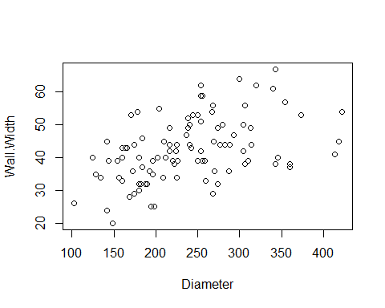

par(mfrow=c(2,2))  
plot(model.Diameter)

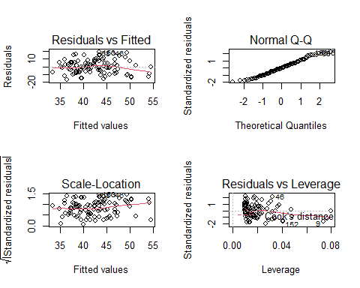

This variable is slightly skewed to the right, but it has a mostly normal curve, as seen in the Q-Q Norm plot. The independence and constant variance assumptions are met in this variable, because the residuals look regularly varied and there is no distinguishable pattern in them.

model.diagonal <- lm(Wall.Width~Diagonal.Diameter, data=chullpas1)  
par(mfrow=c(2,2))  
plot(model.diagonal)

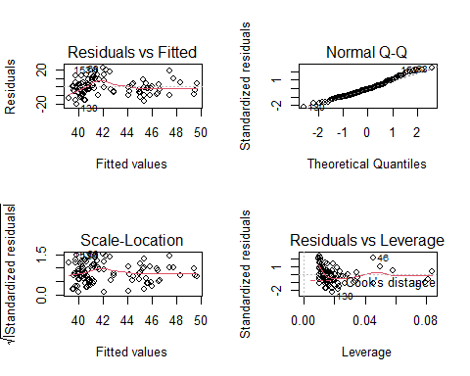

hist(chullpas1$Diagonal.Diameter, xlab="Diagonal", main="Diagonal Normality")

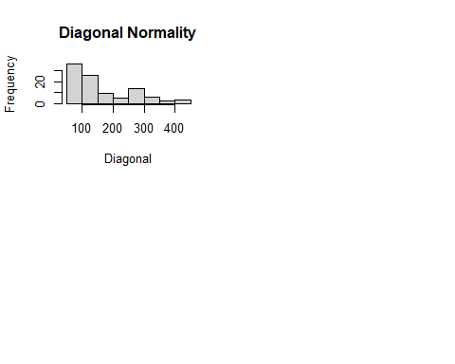 There is a clear pattern in the residuals and the normality assumption is violated, so this variable isn’t a good candidate for the model. This process was repeated for every variable, but with limited space, I only included what I felt were important variables.

#create full model  
full.model2 <- lm(Wall.Width~.-Diagonal.Diameter-ï..Site+site.f, data=chullpas1)  
summary(full.model2)

##   
## Call:  
## lm(formula = Wall.Width ~ . - Diagonal.Diameter - ï..Site + site.f,   
## data = chullpas1)  
##   
## Residuals:  
## Min 1Q Median 3Q Max   
## -14.8622 -5.2847 -0.3042 4.2984 17.6601   
##   
## Coefficients:  
## Estimate Std. Error t value Pr(>|t|)   
## (Intercept) 40.453608 8.979094 4.505 2.05e-05 ***  
## Front.wall.length -0.007483 0.030413 -0.246 0.80623   
## Door.width 0.093940 0.127132 0.739 0.46195   
## Diameter 0.044083 0.018934 2.328 0.02222 *   
## site.fb -20.782269 6.216369 -3.343 0.00122 **   
## site.fc -0.709235 6.082031 -0.117 0.90744   
## site.fd -8.808111 5.934315 -1.484 0.14135   
## site.fe -13.655184 6.042284 -2.260 0.02632 *   
## site.ff -20.105587 5.993395 -3.355 0.00118 **   
## site.fg -10.973000 5.961922 -1.841 0.06910 .   
## site.fh -11.801625 6.819546 -1.731 0.08708 .   
## site.fi -11.397586 5.608781 -2.032 0.04519 *   
## site.fj -6.202162 6.403258 -0.969 0.33543   
## site.fk -13.162867 5.683671 -2.316 0.02292 *   
## site.fl -6.653179 7.538331 -0.883 0.37990   
## ---  
## Signif. codes: 0 '***' 0.001 '**' 0.01 '*' 0.05 '.' 0.1 ' ' 1  
##   
## Residual standard error: 7.455 on 87 degrees of freedom  
## Multiple R-squared: 0.4879, Adjusted R-squared: 0.4055   
## F-statistic: 5.921 on 14 and 87 DF, p-value: 5.297e-08

#look for multicollinearity  
car::vif(full.model2)

## GVIF Df GVIF^(1/(2*Df))  
## Front.wall.length 3.230104 1 1.797249  
## Door.width 1.570293 1 1.253113  
## Diameter 3.121764 1 1.766852  
## site.f 4.289320 11 1.068427

There are no values in the multicollinearity test greater than 10 or less than 0.5, so these variables can proceed to the next step.

#AIC  
step.model <- step(full.model2,data=chullpas1,direction ="both",trace=0)  
summary(step.model)

##   
## Call:  
## lm(formula = Wall.Width ~ Diameter + site.f, data = chullpas1)  
##   
## Residuals:  
## Min 1Q Median 3Q Max   
## -14.8196 -5.2332 -0.4133 4.3118 18.1651   
##   
## Coefficients:  
## Estimate Std. Error t value Pr(>|t|)   
## (Intercept) 43.60363 6.26398 6.961 5.54e-10 ***  
## Diameter 0.04478 0.01561 2.869 0.005142 **   
## site.fb -20.82062 6.13840 -3.392 0.001037 **   
## site.fc -1.12148 5.91023 -0.190 0.849935   
## site.fd -9.35565 5.78741 -1.617 0.109514   
## site.fe -13.91771 5.98254 -2.326 0.022269 *   
## site.ff -20.36924 5.88247 -3.463 0.000824 ***  
## site.fg -10.80767 5.88490 -1.837 0.069621 .   
## site.fh -11.48507 6.75018 -1.701 0.092350 .   
## site.fi -11.14280 5.55319 -2.007 0.047832 *   
## site.fj -6.88833 6.28566 -1.096 0.276088   
## site.fk -14.00220 5.52518 -2.534 0.013017 *   
## site.fl -6.67938 7.47703 -0.893 0.374095   
## ---  
## Signif. codes: 0 '***' 0.001 '**' 0.01 '*' 0.05 '.' 0.1 ' ' 1  
##   
## Residual standard error: 7.394 on 89 degrees of freedom  
## Multiple R-squared: 0.4846, Adjusted R-squared: 0.4151   
## F-statistic: 6.973 on 12 and 89 DF, p-value: 9.41e-09

#address assumptions in new model  
plot(Wall.Width~Diameter, col=site.f, data=chullpas1)

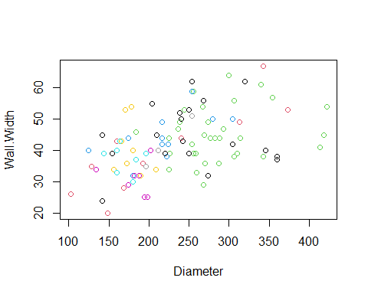

par(mfrow=c(2,2))  
plot(step.model)

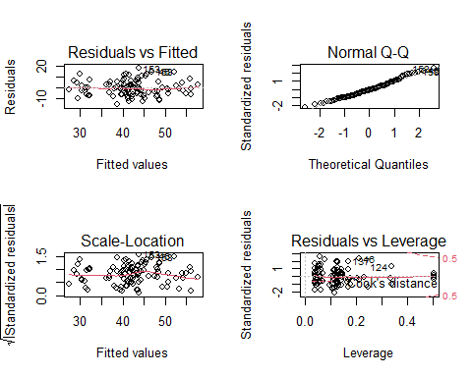

The AIC has chosen Diameter and Site as important variables for the model. The normality assessed by the Q-Q Norm plot is not the strongest, but it is acceptable. However, there is an almost funnel shape to the residual plot, suggesting that transformation may be necessary for the equal variance assumption to hold.

#log transformation  
step.model3 <- lm(Wall.Width~log(Diameter)+site.f, data=chullpas1)  
summary(step.model3)

##   
## Call:  
## lm(formula = Wall.Width ~ log(Diameter) + site.f, data = chullpas1)  
##   
## Residuals:  
## Min 1Q Median 3Q Max   
## -13.8014 -5.3021 -0.3447 4.1000 17.7335   
##   
## Coefficients:  
## Estimate Std. Error t value Pr(>|t|)   
## (Intercept) -6.4830 21.3407 -0.304 0.76200   
## log(Diameter) 11.1178 3.8352 2.899 0.00471 **  
## site.fb -19.4973 6.2289 -3.130 0.00236 **  
## site.fc -0.9929 5.8975 -0.168 0.86668   
## site.fd -9.0463 5.7883 -1.563 0.12164   
## site.fe -13.2596 6.0105 -2.206 0.02996 *   
## site.ff -19.8532 5.8989 -3.366 0.00113 **  
## site.fg -10.3147 5.9007 -1.748 0.08391 .   
## site.fh -11.4498 6.7442 -1.698 0.09305 .   
## site.fi -10.8138 5.5382 -1.953 0.05401 .   
## site.fj -6.5188 6.2572 -1.042 0.30032   
## site.fk -13.7844 5.5043 -2.504 0.01409 *   
## site.fl -6.6209 7.4659 -0.887 0.37757   
## ---  
## Signif. codes: 0 '***' 0.001 '**' 0.01 '*' 0.05 '.' 0.1 ' ' 1  
##   
## Residual standard error: 7.388 on 89 degrees of freedom  
## Multiple R-squared: 0.4855, Adjusted R-squared: 0.4161   
## F-statistic: 6.999 on 12 and 89 DF, p-value: 8.774e-09

par(mfrow=c(2,2))  
plot(step.model3)

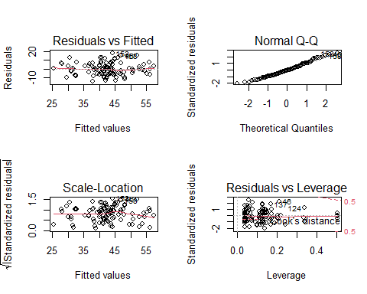

#outlier test (Prabhakaran 2016).  
cooksd <- cooks.distance(step.model3)  
plot(cooksd, pch="*", cex=0.75, main="Cooks Distance: Influential Obs")  
abline(h = 4*mean(cooksd, na.rm=T), col="green")  
text(x=1:length(cooksd)+6, y=cooksd, labels=ifelse(cooksd>4*mean(cooksd, na.rm=T),names(cooksd),""), cex=0.75, col="red")

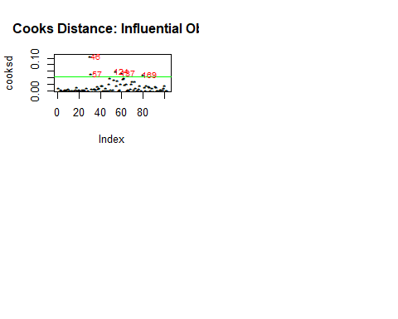

Cooks Distance: Influential Observations

Even with transformations, the adjusted R-squared value is relatively low. Taking the log of Diameter produced the one of the highest r-squared values, but it is still below 0.5. However, this low R-squared value can be explained by natural human variance - the sites were built by real people and humans are incredibly unpredictable. A majority of the variables are still significant, and the transformation increases the equal variance of the model.

Observation 46 is in site Rayallaqta, and it has a high value for both Diameter and Wall Width. It will still be included in the model because it is a natural part of the observed data set, and I have no reason to believe that its recorded value was a mistake. It does most likely influence the model, but I think the analysis is still valid with the inclusion of this point.

Observations 57, 124, 137, and 169 are fairly close to the cutoff line (which I assigned to 4 times the mean), so I conclude that these are close enough to be part of the analysis.

#### Results and Discussion

#plot all points together using model found by AIC and transformations  
require(ggplot2)  
qplot(log(Diameter), Wall.Width, data = chullpas1, color = ï..Site, xlab="Diameter", ylab="Wall Width")

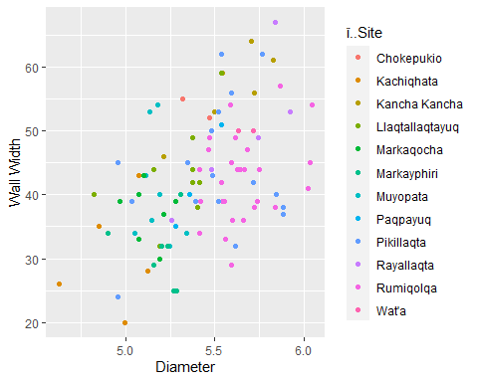

There seems to be an overall pattern of increasing Wall Width as Diameter increases, but as the next few plots show, the individual sites have different patterns:

#plot each site on its own scatterplot  
p <- ggplot(chullpas1) + aes(log(Diameter), Wall.Width)  
p + geom_point(aes(colour=ï..Site))+geom_smooth(method="lm")+ facet_wrap( ~ ï..Site)

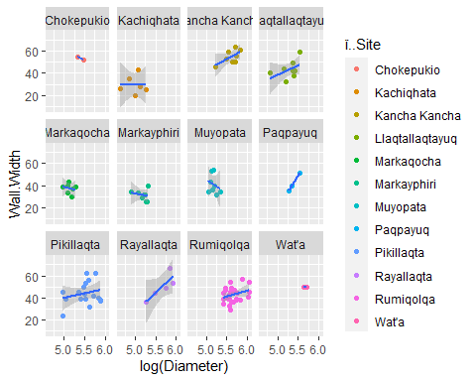## `geom_smooth()` using formula 'y ~ x'

As shown in some of these plots, there are sites that do not have much data: Chokepukio, Wat’a, and Paqpayuq have only a few data points, so their results could be incorrect. I wanted to include these sites in my analysis despite their problems with small sample size because they are still an important part of the research conducted by the original archaeology project.

Similarities within sites can be seen in this graph. Several sites have a cluster of data points around the same wall width, such as Chokepukio(a), Kancha Kancha(c), Markaqocha(e), Markayphiri(f), Rumiqolqa(k), and Wat’a(l). Some sites even have a cluster around the a wall width value and a diameter value, such as Markaqocha(e), Wat’a(l), and the left side of the Rumiqolqa(k) graph. This suggests that there could be standardization of chullpa wall width and diameter within sites: many of the data points are clustered near each other, meaning that in these sites, the chullpas had around the same values for these measurements in many chullpas. The main goal of this project is to explore the standardization between sites, but this inclusion shows that standardization could have been common both within and between sites.

The similarities between sites can be also be seen here. The placement, direction, and strength are similar between sites Kancha Kancha(c) and Rayallaqta(j), and the placement of these two sites is also similar to that of sites Chokepukio(a) and Wat’a(l). Sites Markaqocha(e), Kachiqhata(b), and Markayphiri(f) also seem to have similar placement and general pattern. Most of the others seem to be similar to each other, but not enough so that I can claim there is a significant relationship at this step. A boxplot is the next step that would aid in answering this question.

#boxplot for levels of site.f  
boxplot(Wall.Width~site.f, data=chullpas1, xlab="Site", ylab="Wall Width",main="Site vs. Wall Width")

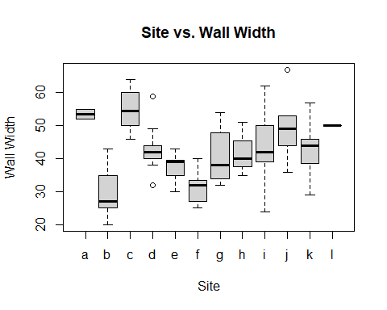

In the boxplot, it is evident that some of the site means will vary by a great amount from others. For example, the medians for site c and b are complete opposites and are very far from each other. Other combinations look like they will be more similar, such as sites e, g, h, i, and k. Because some sites have extremely different medians, it is useful to conduct a comparison test to asses this idea.

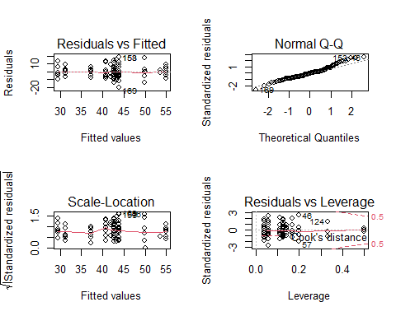aovtest <- aov(Wall.Width~site.f, data=chullpas1)  
par(mfrow=c(2,2))  
plot(aovtest)

Unfortunately, the assumption for normality is violated by the model. The residuals look fairly decent, but because of the normality problem, ANOVA cannot be used in this instance.

#### Hypotheses for Kruskal-Wallis

$H_{0}:asite median=bsite median=csite median=...=0$ $H_{A}:At least one site≠0$

#Kruskal-Wallis test on levels of site.f (Mangiafico 2016).   
kruskal.test(Wall.Width~site.f,data=chullpas1)

##   
## Kruskal-Wallis rank sum test  
##   
## data: Wall.Width by site.f  
## Kruskal-Wallis chi-squared = 42.99, df = 11, p-value = 1.091e-05

#Posthoc Test (Dinno 2014; dunnTest function).  
library(FSA)

## Warning: package 'FSA' was built under R version 4.0.3

## ## FSA v0.8.31. See citation('FSA') if used in publication.  
## ## Run fishR() for related website and fishR('IFAR') for related book.

dunnTest(Wall.Width~site.f, data=chullpas1)

## Dunn (1964) Kruskal-Wallis multiple comparison

## p-values adjusted with the Holm method.

## Comparison Z P.unadj P.adj  
## 1 a - b 2.96960978 2.981782e-03 1.729434e-01  
## 2 a - c -0.01337355 9.893298e-01 9.893298e-01  
## 3 b - c -4.50920485 6.507105e-06 4.229618e-04  
## 4 a - d 1.43301328 1.518540e-01 1.000000e+00  
## 5 b - d -2.47499751 1.332371e-02 6.528618e-01  
## 6 c - d 2.32718928 1.995519e-02 9.578493e-01  
## 7 a - e 2.28164019 2.251059e-02 1.000000e+00  
## 8 b - e -1.07000219 2.846183e-01 1.000000e+00  
## 9 c - e 3.55513021 3.777920e-04 2.417869e-02  
## 10 d - e 1.40716392 1.593788e-01 1.000000e+00  
## 11 a - f 3.08928904 2.006361e-03 1.203817e-01  
## 12 b - f 0.03262811 9.739712e-01 1.000000e+00  
## 13 c - f 4.90574029 9.307562e-07 6.142991e-05  
## 14 d - f 2.72077583 6.512891e-03 3.386703e-01  
## 15 e - f 1.18426518 2.363081e-01 1.000000e+00  
## 16 a - g 1.84019988 6.573890e-02 1.000000e+00  
## 17 b - g -1.79585119 7.251819e-02 1.000000e+00  
## 18 c - g 2.93075691 3.381373e-03 1.927382e-01  
## 19 d - g 0.68853470 4.911161e-01 1.000000e+00  
## 20 e - g -0.72375003 4.692192e-01 1.000000e+00  
## 21 f - g -1.97498337 4.827003e-02 1.000000e+00  
## 22 a - h 1.37128870 1.702850e-01 1.000000e+00  
## 23 b - h -1.65868391 9.717950e-02 1.000000e+00  
## 24 c - h 1.86466224 6.222876e-02 1.000000e+00  
## 25 d - h 0.19735737 8.435479e-01 1.000000e+00  
## 26 e - h -0.83698189 4.026027e-01 1.000000e+00  
## 27 f - h -1.75846707 7.866807e-02 1.000000e+00  
## 28 g - h -0.29984518 7.642952e-01 1.000000e+00  
## 29 a - i 1.46557352 1.427645e-01 1.000000e+00  
## 30 b - i -2.79892905 5.127240e-03 2.819982e-01  
## 31 c - i 2.57997435 9.880765e-03 4.940383e-01  
## 32 d - i -0.05981072 9.523064e-01 1.000000e+00  
## 33 e - i -1.63397517 1.022641e-01 1.000000e+00  
## 34 f - i -3.14105277 1.683417e-03 1.026884e-01  
## 35 g - i -0.83784616 4.021171e-01 1.000000e+00  
## 36 h - i -0.24947520 8.029932e-01 1.000000e+00  
## 37 a - j 0.70361774 4.816709e-01 1.000000e+00  
## 38 b - j -3.03203340 2.429123e-03 1.433183e-01  
## 39 c - j 1.05117430 2.931785e-01 1.000000e+00  
## 40 d - j -0.95298418 3.405981e-01 1.000000e+00  
## 41 e - j -2.11888691 3.410003e-02 1.000000e+00  
## 42 f - j -3.25144456 1.148202e-03 7.233670e-02  
## 43 g - j -1.51926956 1.286947e-01 1.000000e+00  
## 44 h - j -0.90801549 3.638700e-01 1.000000e+00  
## 45 i - j -0.99635636 3.190770e-01 1.000000e+00  
## 46 a - k 1.59533653 1.106370e-01 1.000000e+00  
## 47 b - k -2.78189699 5.404219e-03 2.918278e-01  
## 48 c - k 2.93060397 3.383038e-03 1.894501e-01  
## 49 d - k 0.12696654 8.989669e-01 1.000000e+00  
## 50 e - k -1.55673962 1.195323e-01 1.000000e+00  
## 51 f - k -3.16290438 1.562036e-03 9.684625e-02  
## 52 g - k -0.70974197 4.778642e-01 1.000000e+00  
## 53 h - k -0.13589347 8.919055e-01 1.000000e+00  
## 54 i - k 0.23747439 8.122888e-01 1.000000e+00  
## 55 j - k 1.19215639 2.331999e-01 1.000000e+00  
## 56 a - l 0.27066153 7.866514e-01 1.000000e+00  
## 57 b - l -2.63811846 8.336745e-03 4.251740e-01  
## 58 c - l 0.35573631 7.220380e-01 1.000000e+00  
## 59 d - l -1.08678188 2.771332e-01 1.000000e+00  
## 60 e - l -1.94406594 5.188750e-02 1.000000e+00  
## 61 f - l -2.74692627 6.015666e-03 3.188303e-01  
## 62 g - l -1.49783711 1.341756e-01 1.000000e+00  
## 63 h - l -1.07479385 2.824670e-01 1.000000e+00  
## 64 i - l -1.10350631 2.698074e-01 1.000000e+00  
## 65 j - l -0.38011533 7.038598e-01 1.000000e+00  
## 66 k - l -1.22599817 2.201994e-01 1.000000e+00

Because the p-value for the Kruskal-Wallis test is lower than 0.05, we can reject the null hypothesis and conclude that at least one of the levels’ medians in the factor “site” differs significantly from 0.

By comparing the p-adj values listed in the Dunn Test, the areas where differences were found could be more highly scrutinized. The starkest differences lie in the c-b, c-e, and c-f comparisons, which makes sense based on the boxplot visualization: the medians are very far away from each other in these 3 cases. Because this project seeks to find standardization, I also took into account the very large p-values. There are many comparisons that are either close to 1.000 or are equal to 1.000, which is expected only from a distribution that barely differs at all.

Based on the Dunn Test results, I categorize the sites into four major, although amorphous, groups: site c is alone in group 1, sites a, d, h, i, j, k, and l are in group 2, and sites e and g are in group 3, and sites b and f are in group 4. Within the groups, the sites had very high p-values and were not significantly different in medians. It is telling that there is a large group of sites that seem to compare well to most of the other sites. In this order, the sites seem to be most related:

1. Site C
2. Site A, Site D, Site H, Site I, Site J, Site L, Site K
3. Site E, Site G
4. Site B, Site F

Group 2 has the most sites, and many of these also have high p-values when compared to other groups. Sites a-l have high p-values against site c, and all have high values when compared to sites e and g. However, group 2 does not always display high p-values when compared to group 4: sites e and g are those that compare well to the final group. Site h was the only site that had a p-adj value of 1.000 when compared to every other site.

The groupings I have discussed here are amorphous in quality, so it is possible that other interesting groupings could be made, but I see these groupings as being the most helpful in illustrating the p-values reported in the Dunn test.

#### Conclusions

Between the sites explored in this project, there is a level of similarity in Diameter and Wall Width. The boxplot, Kruskal-Wallis, and Dunn test lend evidence for standardization of Wall Width in the Inka region during the time of building these sites. Furthermore, with all the sites plotted in the same scatterplot, the general trend seems to be that with increasing log diameter, wall width increases as well.

Each individual site has its own pattern, placement, and strength, but many of them, namely those excluding sites c, b, and f, have more similarities than differences. This opens the case for standardization of these variables within chullpas throughout the pre-Inka period.

If the claims of the Inka to the Spanish were indeed true, the evidence for standardization would not exist. The Inka claimed that the Andean people did not have regional systems, politics, or communication before the existence of the Inka Empire. If they were not standardized and had little to no contact with each other, we would expect that there would not be any instances of p-adj values as high as 1.000 or 0.999 in the Dunn test: many of the comparisons show evidence for standardization in their wall widths based on site because there is little to no variance in their medians. We would also not expect similar shapes of the scatterplots. Because both of these factors are present, we can conclude that the case for communication and contact between these sites is still open and not disproved by the analysis done in this project.

The evidence suggests that the behavior of standardization was not only a product of the empire’s control: the people of the Andes may have had a regional system of trade and communication before they were subjugated by the Inka Empire.

**References**

Binford, L. (1965). Archaeological Systematics and the Study of Culture Process. *American*

*Antiquity,* *31*(2), 203-210. doi:10.2307/2693985

Costin, C., & Hagstrum, M. (1995). Standardization, Labor Investment, Skill, and the

Organization of Ceramic Production in Late Prehispanic Highland Peru. American

Antiquity, 60(4), 619-639. doi:10.2307/282046

Dinno, A. (2014). *dunn.test package.* R documentation.

<https://www.rdocumentation.org/packages/dunn.test>.

*dunnTest function.* R documentation.

<https://www.rdocumentation.org/packages/FSA/versions/0.8.31/topics/dunnTest>

*ggplot2 box plot : Quick start guide - R software and data visualization.* sthda.com.

<http://www.sthda.com/english/wiki/ggplot2-box-plot-quick-start-guide-r->

software-and-data-visualization

*Inca Civilization Timeline*. Ancient.eu.

<https://www.ancient.eu/timeline/Inca_Civilization/?timeline_search=timeline_sear>

ch&tl_date_from=&tl_date_from_bc_ad=BC&tl_date_to=&tl_date_to_bc_ad=BC&tl_key

words=Inca_Civilization&timeline_types=9%2C5%2C10%2C11%2C12%2C7%2C13%2C1%2C4

Kosiba, S. (2009). KosibaAnalysis_chullpa 6, Wat’a Archaeological Project. [Archaeological survey].

Raw data from site.

Kosiba, S. (2020). Week 13, Video 2: Andean people during Inka ascendancy. [Video lecture].

Retrieved from https://canvas.umn.edu/courses/188498/external_tools/24.

Mangiafico, S*.* (2016). Kruskal–Wallis Test. *Summary and Analysis of Extension Program Evaluation*

*in R.* Rutgers Cooperative Extension. <https://rcompanion.org/handbook/A_02.html>

Neitzel, J. (2000). What Is a Regional System? Issues of Scale and Interaction in the Prehistoric

Southwest. In Hegmon M. (Ed.), *The Archaeology of Regional Interaction: Religion, Warfare, and Exchange across the American Southwest and Beyond* (pp. 25-40). University Press of Colorado. Retrieved November 27, 2020, from <http://www.jstor.org/stable/j.ctt46nvvq.7>

Prabhakaran, S. (2016). *Outlier Treatment*. r-statistics.co. <http://r-statistics.co/Outlier->

Treatment-With-R.html